1. One source table Student Table: <40--Fail, >40--Pass, First Division>60  
     
   Three Destination Table:  
   Student_Fail, Student_Pass, Student_FD:

**create** **table** LV_result(

r_id **int**,

name **varchar**(255),

marks **int**

);

**insert** **into** LV_result **values**(1,'aman',70),(2,'ram',40),(3,'sita',50),(4,'gita',90);

**create** **table** NV_result1(

r_id **int**,

name **varchar**(255),

marks **int**

);

**create** **table** NV_result2(

r_id **int**,

name **varchar**(255),

marks **int**

);

**select** * **from** LV_result2

**create** **table** NA_result3(

r_id **int**,

name **varchar**(255),

marks **int**

);

**select** * **from** LV_result3

2.Sales that contain three years of data-2020,2021,2022  
  
Sales_YR_2022,Sales_YR_2021,Sales_YR_2022

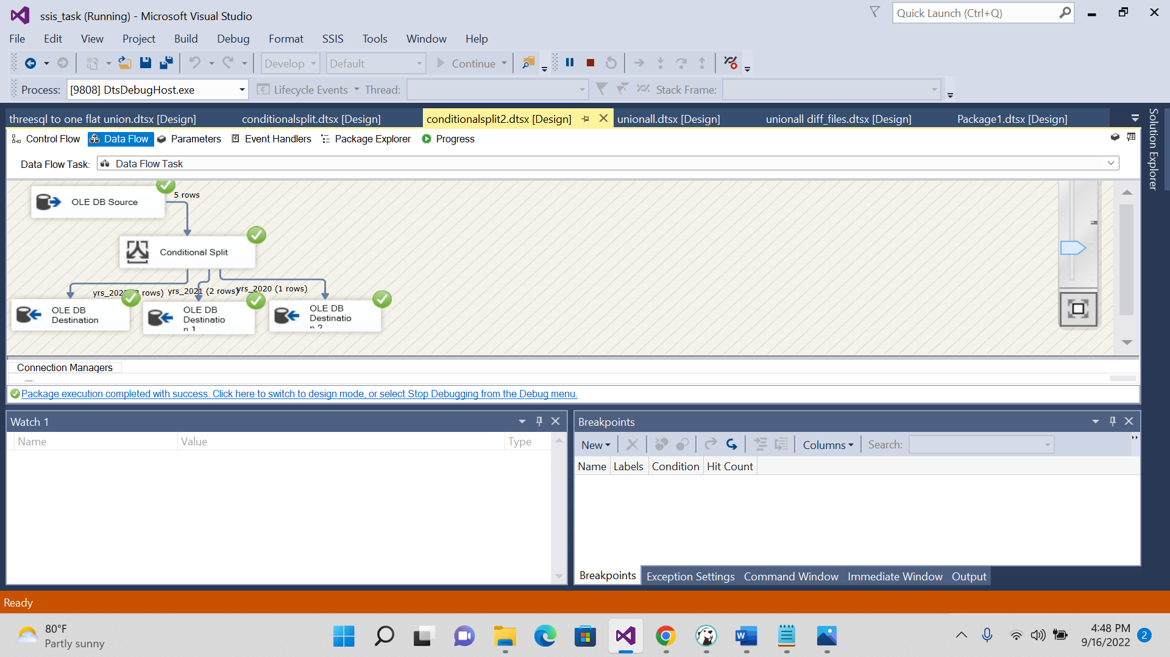

**create** **table** LV_SALEYRS(

s_year **int**,

s_item **int**,

s_name **varchar**(50)

);

**insert** **into** LV_SALEYRS **values**(2022,500,'washingmachine')

**insert** **into** LV_SALEYRS **values**(2021,400,'acmachine')

**insert** **into** LV_SALEYRS **values**(2020,100,'microwavee')

**insert** **into** LV_SALEYRS **values**(2022,50,'machine')

**insert** **into** LV_SALEYRS **values**(2021,300,'gas')

**create** **table** LV_SALEYRS_2022(

s_year **int**,

s_item **int**,

s_name **varchar**(50)

);

**create** **table** LV_SALEYRS_2021(

s_year **int**,

s_item **int**,

s_name **varchar**(50)

);

**create** **table** LV_SALEYRS_2020(

s_year **int**,

s_item **int**,

s_name **varchar**(50)

);

